**QForm Layout**

QForm Layout is a convenient way to create a form with two columns and multiple rows.

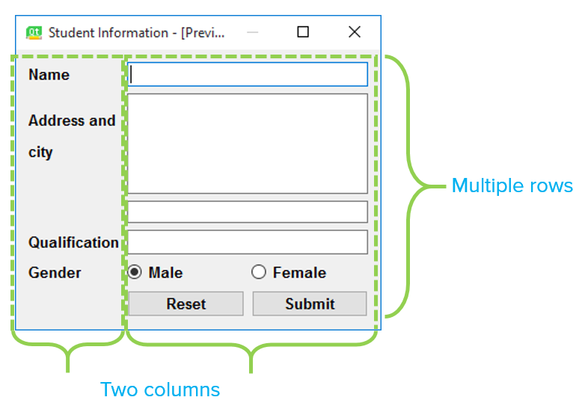

Each row consists of an input field associated with a label. As a convention, the left column contains the label while the right column contains an input field. The QFormLayout class has a setWidget() method. Its usage is:

**QFormLayout.setWidget(rownum, role, widget)**

The role parameter has two possible values, LabelRole and FieldRole. We shall now design a student information form in the Form Layout. The broad process we will follow is:

* Create a new form.
* Roughly place all the required widgets into the form.

Use the Layout option, Form layout which will automatically arrange our widgets. Let's look at the steps:

Step1:

* Start Qt Designer.
* Create a new form using the template, Widget.
* Use the Layout option, Form layout which will automatically arrange our widgets. Let's look at the steps.

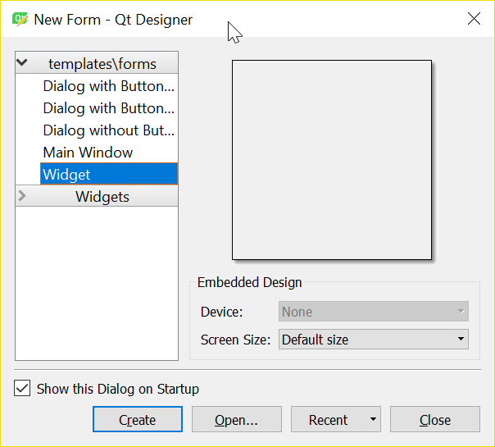

Step 2:

* Let's first place widgets for the right column. You can just drag them and drop them anywhere.
  1. Two LineEdit widgets (Name, Qualification)
  2. One vertical layout (For holding Address and City)
  3. Two horizontal layout objects (one for holding the gender radio buttons and the other for the Reset and Submit buttons)

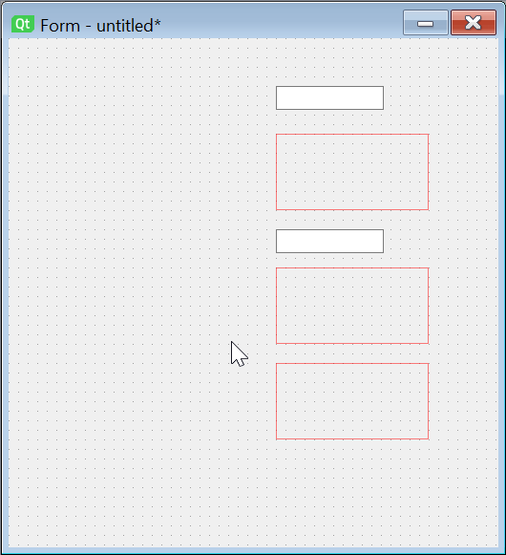

Step 3:

* Let's now place the text labels in the left column.

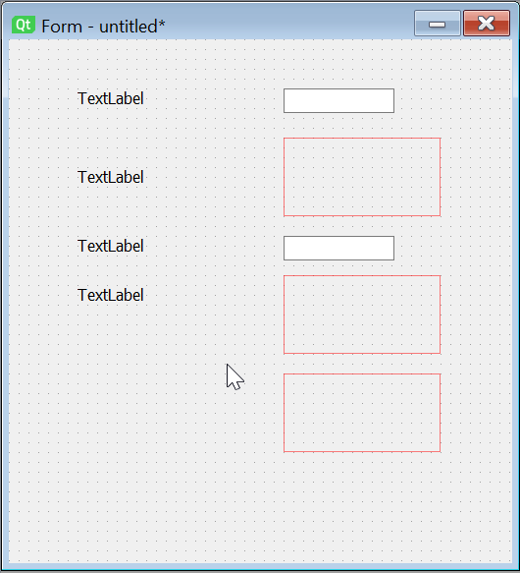

Step 4:

* Now, let's place the required elements into the layouts.
  1. First, we place a multi-line text box(address) and a LineEdit (City) widget in the vertical layout.
  2. Next, we place two radio buttons (Male, Female) in one horizontal layout.
  3. Finally we place two push buttons(Reset, Submit) in the second horizontal layout.

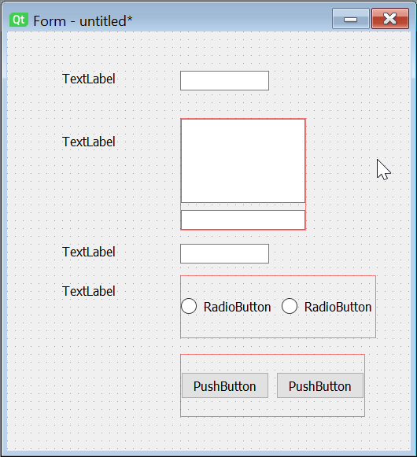

Step 5:

* Finally, we right-click on QWidget in the Object Inspector Window and select Layout - lay out in form layout.

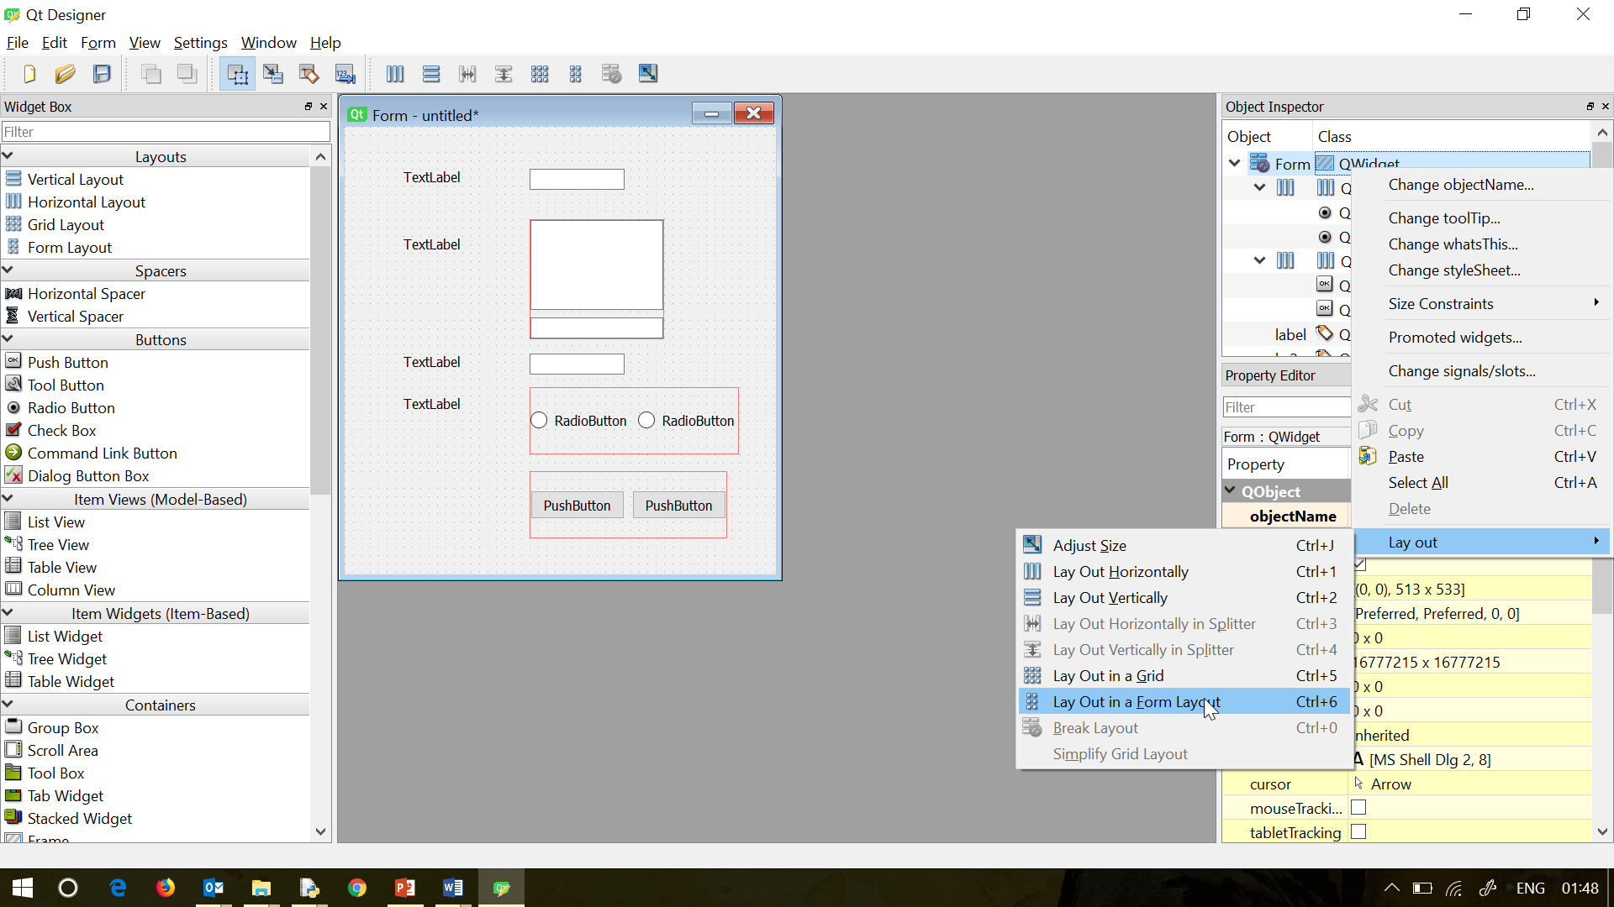

And the widgets are arranged.

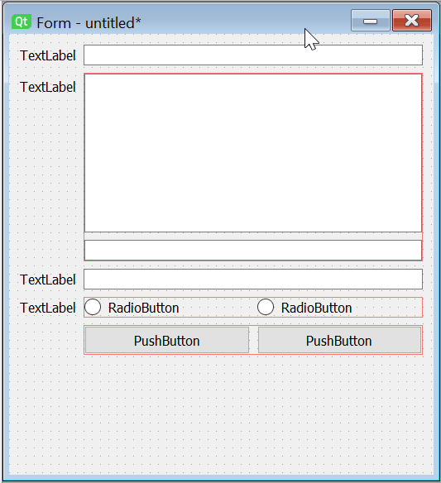

You can customize the labels and buttons captions before saving the ui file and generating the py file.

Final output:

